**Lesson 3: Multiplying and Dividing Integers**

**Do Now:**

**Solve the following problems. Solve the problems using the hot cubes/ice cubes, or using the VIP from the previous lesson.**

1. -2 – (-5) +7
2. 4+5-10
3. 9-10+(-1)
4. -7+(-10)-16
5. 2-8+3

**Key Vocabulary:**

**Guided Notes:**

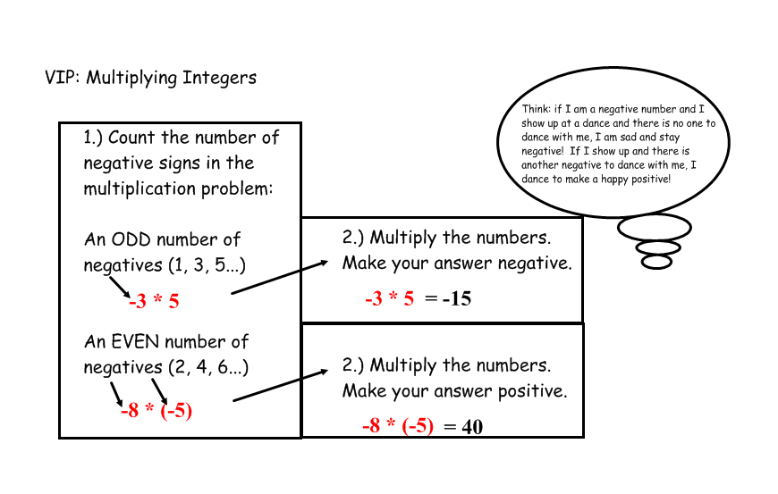

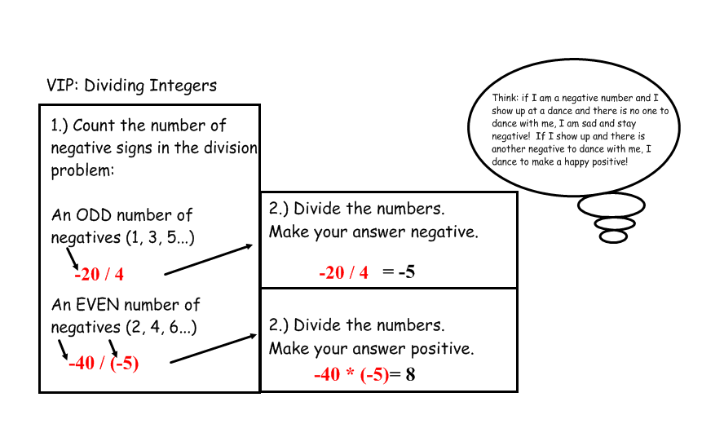

**Multiplication:**

1. 5*-7
2. -3*-7
3. -9*0
4. 2*8
5. 8*-7
6. -4*-7
7. -3*2
8. -5 * -2 * -1 * ½ * 3 * -2
9. -1*-1*1*-1*1*-1*1*1*-1*-1*1*-1*1*1*-1*-1*-1

**Division:**

1. 20/-2
2. -10/-5
3. -8/2
4. 4/2
5. 500/-10
6. -100/2
7. -40/-8
8. 2*(4/-2)*(12/3)*-1*(-2/-1)*(-4/2)

$\frac{-1×-2×-6}{-2×-4×-3}$

**Structured/Guided Practice:**

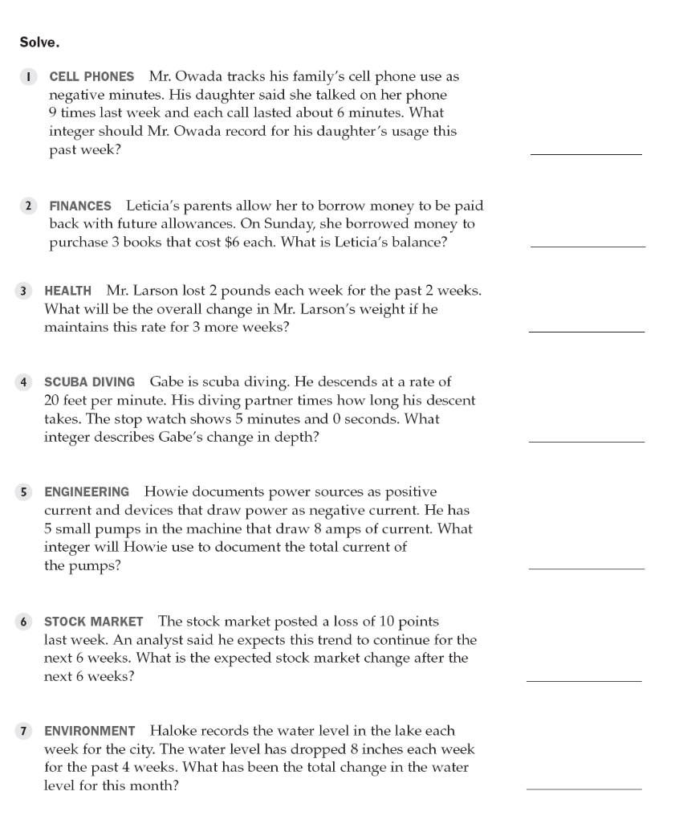

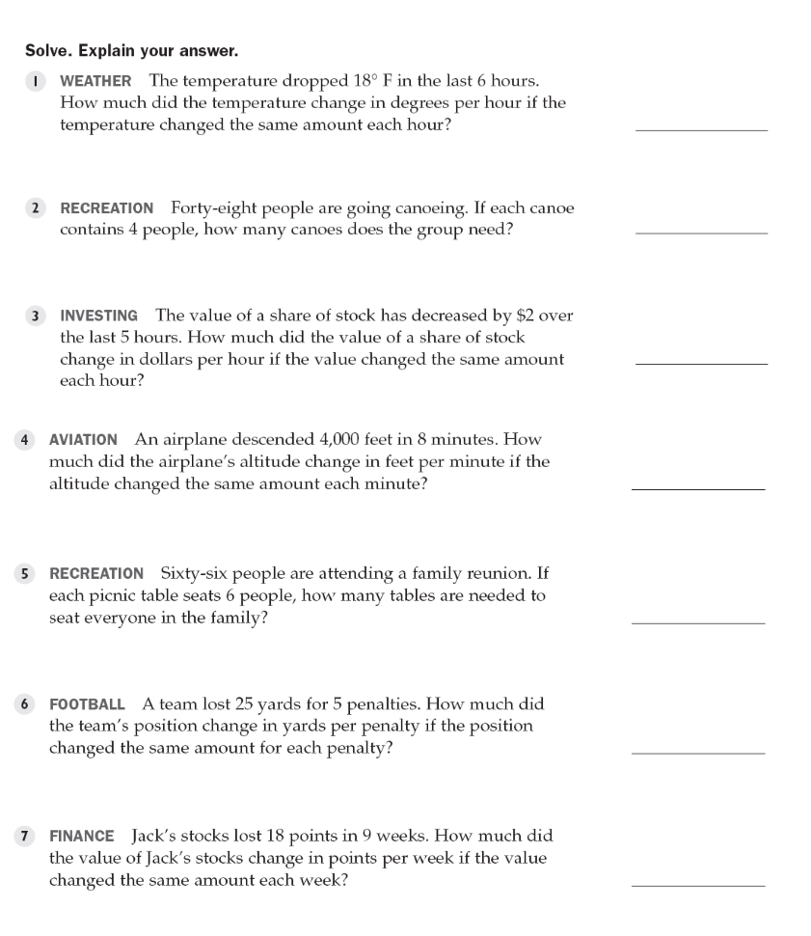

**Independent Practice:**

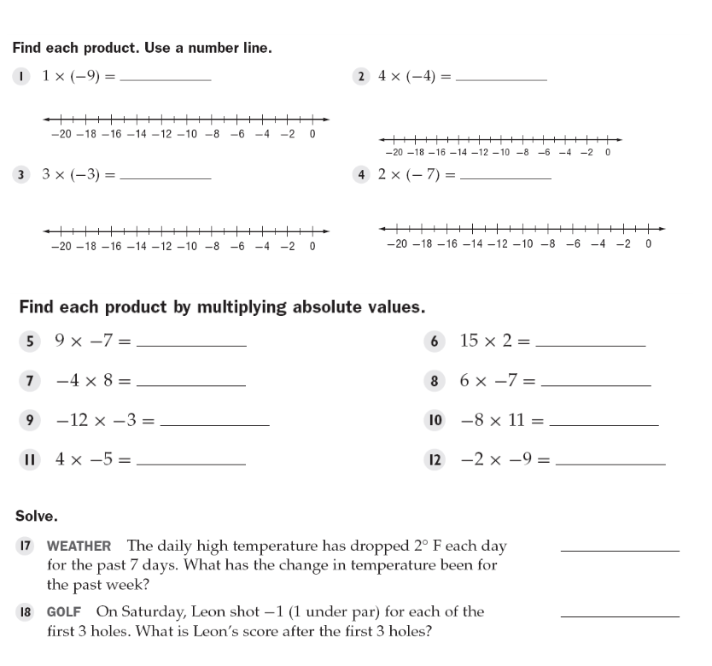

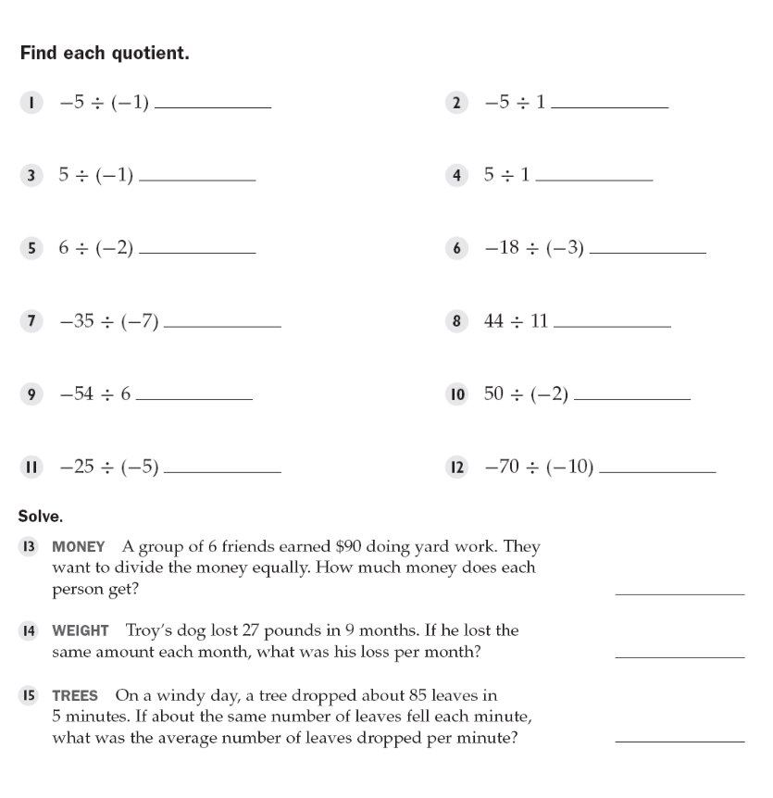

**Closure:**

